
PYTHON PROGRAMMING LAB FILE

Name: Yogesh Dinesh Joshi
Sap ID: 590025632
Batch: 34
Teacher: Sugandha Sharma

Experiment-6

Objective 1: Function to Find Maximum and Minimum (Without Built-in Functions)
Code:
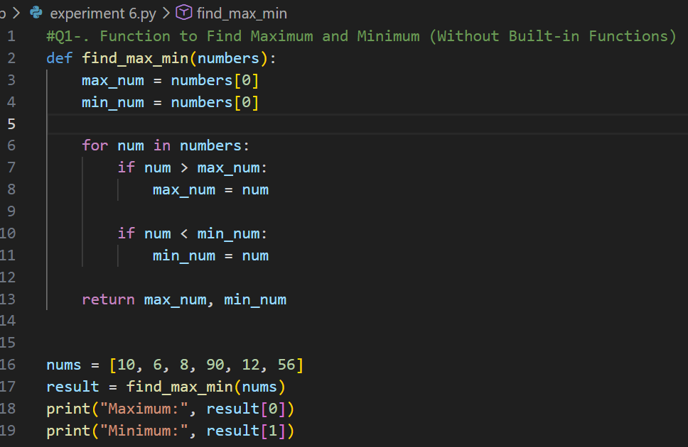
Output:
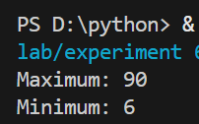

Objective 2: Sum of Cubes of Numbers Smaller Than n
Code:
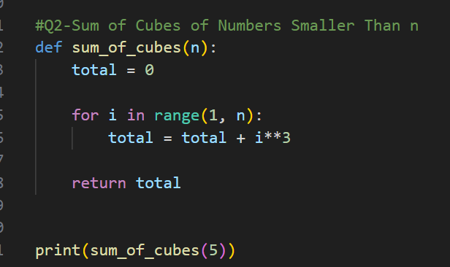
Output:
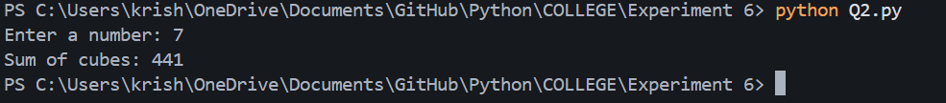
Objective 3: Print 1 to n Using Recursion (No Loop)
Code:
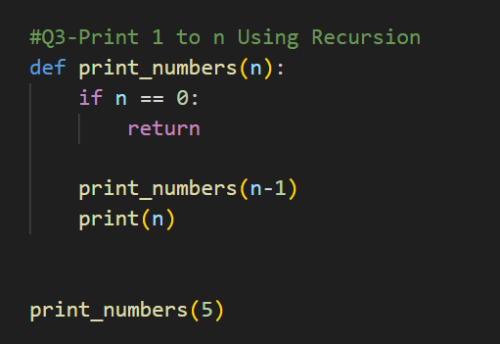
Output:
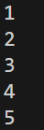
Objective 4: Fibonacci Series Using Recursion
Code:
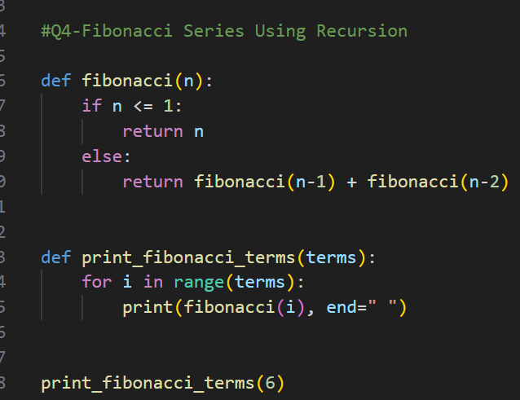
Output:
Objective 5: Lambda Function to Find Volume of Cone
Code:
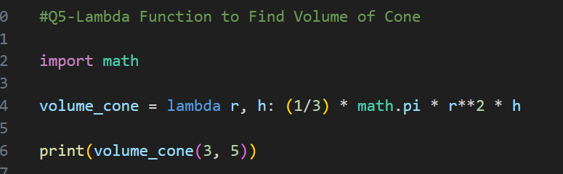
Output:
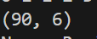

Objective 6: Lambda to Return Tuple of Max and Min
Code:
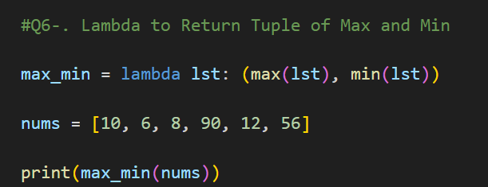
Output:

Objective 7: Types of Function Arguments
A: Keyword Arguments
Code:
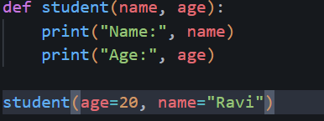
Output:
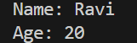

B: Default Arguments
Code:
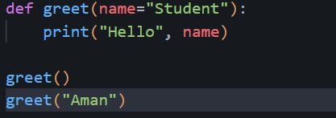
Output:
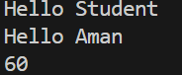
C: Variable Length Arguments
Code:
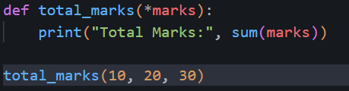
Output:
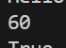

Objective 8:
Code:
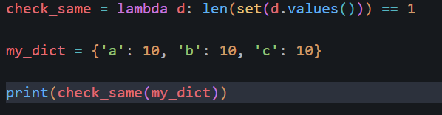
Output:

Objective 9: Check if All Dictionary Values are Same (Using Lambda)
Code:
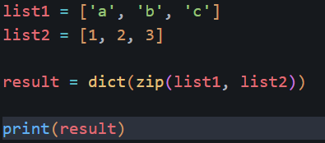
Output:
